Silver City Energy Storage Project
WEBSITE (Procurement)

Procurement plays a vital role in bringing our Advanced Compressed Air Energy Storage (A-CAES) project to life. We are committed to sourcing high-quality, sustainable materials and services that support both technical excellence and local economic growth. Our approach prioritizes safety, environmental responsibility, and long-term value, while fostering strong relationships with local suppliers, contractors, and communities.
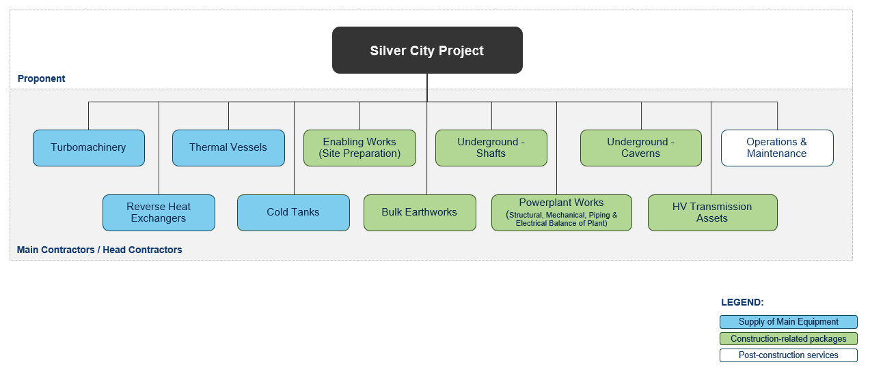
Our procurement contracting strategy is designed to be transparent, inclusive, and performance-driven. We adopt a hybrid approach that balances competitive tendering with strategic partnerships to ensure the best outcomes for the project and the communities we serve. Key work packages for the project includes:
Figure 1: Silver City Energy Storage Contracting Strategy

We believe in building with the community, not just in it. That’s why we actively seek to engage local businesses and service providers who share our values of innovation, integrity, and sustainability. If you're a supplier or contractor interested in contributing to a cleaner, more resilient energy future, we’d love to hear from you. We have partnered with both ICN and NSWICC to support us through this process.
As well as the above key packages, the project will be seeking proposals associated with many smaller packages, including piping, accommodation, electrical equipment and cabling. These opportunities are detailed via ICN and NSW ICC per links below. Get in touch with our procurement team by providing your interest in the form below. Alternatively, if you need support you can also contact ICN or NSW with the following details:
Industry Capability Network CN – Link to ICN
NSW Indigenous Chamber of Commerce – Link to NSW ICC

The team will be hosting some Procurement Capability Sessions shortly so watch this space for more information.

